
THIS IS A GREAT INITIATIVE- PLEASE GET INVOLVED-HOPEFULLY IT ALSO FACILITATES DEVELOPING OTHER GATHERINGS, CLASSES AND ACTIVITIES FOR PEOPLE WITH PARKINSONS IN WEST CORK
89% of people with Parkinsons suffer voice issues. Singing groups are a proven way to fight against this and also have many other benefits including sociability, cognitive and mental health benefits in remembering words and through the magical effects of music on the mind.
Eilish is a very qualified and experienced choral conductor and singer. Eilish was the musical director of the Bantry community choir. Before Christmas Eilish held a concert where she performed some of the works of HiIdegard von Bingem from the 12th century! Eilish sourced partial finding from the Creative Ireland Programme. Parkinsons Ireland Cork Branch with the approval of Parkinsons Ireland have also agreed to partially subsidise the singing sessions to reduce the cost to members.
www.parkinsons.ie
April 2025
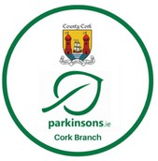
PARKINSONS IRELAND CORK BRANCH MONTHLY NEWSLETTER
NEW SINGING GROUP IN BANTRY FOR THOSE LIVING WITH PARKINSONS, FAMILY, FRIENDS
ART ACTIVITY & FUNDRAISING SPOTLIGHT - JUDDO THE GUITARIST
What a fantastic poster! This was designed by Jud Weidner a member of Parkinsons Ireland Cork Branch from Bantry. Jud is supremely talented. He is truly one of the most inspirational, heart- warming people with Parkinsons who I have ever met. Jud battles Parkinsons through his fantastic graphic art, daily cold water swimming, regular exercise through the neuro gym sessions in Dunmanway, singing, guitar and piano playing and music writing.
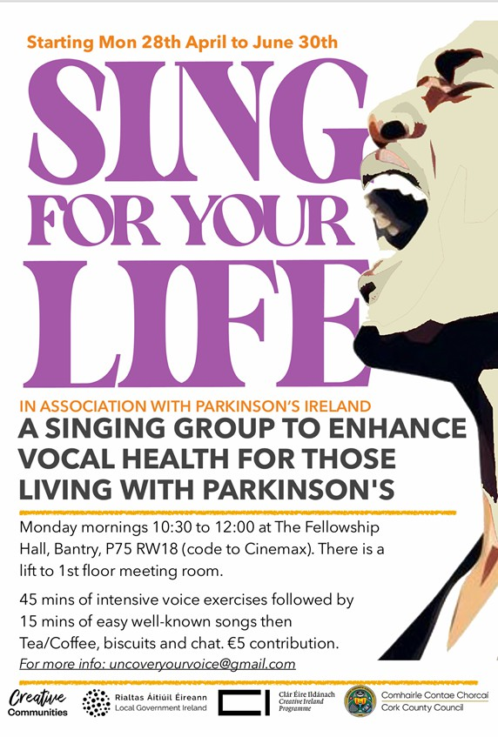
I cannot thank Jud and his family enough for welcoming me to his home in Bantry last December and telling me all about his fantastic art and his fight against Parkinsons. He also donated a beautiful print which raised €350 for the Rocking in the Rockies Fundraiser. Jud introduced me in January to his singing teacher Eilish Butler and Eilish is spearheading a fantastic new opportunity for people with Parkinsons in West Cork-the establishment of a new singing group as outlined in the poster.



April 2025

www.parkinsons.ie

Other Sing?ing Groups??

DON’T FORGET ALSO OUR PERPETUAL MOTION CHOIR GATHERINGS ON MONDAY EVENINGS AT THE LOUGH PARISH CENTRE 7.30 TO 9 (INCLUDING TEA BREAK!)

THE FIRST FRIDAY GATHERING IN YOUGHAL ON MAY 2nd AT YOUGHAL IS ALSO PLANNED TO INCLUDE SINGING, YOUGHAL COMMUNITY HEALTH PROJECT.

WE WERE ALSO APPROACHED SOME TIME AGO BY A SING FOR PARKINSONS INSTRUCTOR IN NORTH KERRY WHO WAS INTERESTED IN SETTING UP A SINGING GROUP IN NORTH/WEST CORK BUT WE HAVEN’T RECEIVED ANY FEEDBACK AS TO WHETHER MEMBERS WOULD BE INTERESTED.

EVERYONE CAN AND PLEASE SHOULD SING FOR THEIR LIVES TO FIGHT PARKINSONS.
Jud is also engaged in a fantastic fundraising project, primarily for the Michael J Fox Foundation where he painstakingly paints with graphic pens amazing art designs on playable guitars. This is an even more amazing feat when you consider Jud was diagnosed with Parkinsons in 2021 and the end results are spectacular.

Jud is hoping in order to enhance the value of the guitars for fundraising purposes that he could then get the guitars signed by some of the artists featured. Sting very kindly obliged!! Sam Fender kindly obliged and the signed guitar then raised stg£5k at auction for an ovarian cancer charity in the UK. I have been trying to help with this project but unfortunately my access to celebrity musicians is somewhat limited! If anyone can genuinely help please contact me on jerome@parkinsons.ie.

Check out: https://www.juddotheguitartist.com/and Jud’s youtube page.



www.parkinsons.ie

April 2025

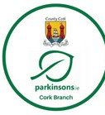
PARKINSONS IRELAND CORK BRANCH-ANNUAL MASS CELEBRATION FOR HEALING, REMEMBRANCE AND THANKSGIVING
SACRED HEART PARISH CHURCH VICTORIA CROSS CORK EIRCODE T12 CA34 EASTER MONDAY 21st APRIL 7.00 PM
TEA AND BISCUITS AFTERWARDS IN THE PARISH HALL

Chief Celebrant: Fr Con Doherty MSC PP
Kind participation of: Rev. Eugene Griffin Rector Kinsale Union of Parishes Congregational singing lead by: Perpetual Motion Parkinsons Ireland Cork Branch Choir Special Guest Conductor: Pat Sheehan Accompanists: Paddy Pollock and Miriam Maume

The Parkinsons Ireland Cork Branch Annual Mass has been a feature of our branch activities since 2014 primarily thanks to the hard work and vision of our amazing Chairman Emeritus Ted Horgan. We also remember the help and kindness of Ted’s uncle who sadly passed away in 2023 after many years service as a priest in latter years in Rochestown and Douglas. We remember all who helped to organize and participate in this annual celebration. We are deeply thankful for the kindness of Rochestown Parish for welcoming and hosting our celebration over the past 10 years. However for a number of primarily practical reasons we asked Fr. Con and the Sacred Heart Parish to please facilitate our celebration this year. We are very grateful that they have kindly agreed to this.
This is for many the highlight of our year and our best attended activity. The solemnity and sincerity of this community mass celebration gives spiritual solace to those of us who are Catholics and we hope to all of our Christian brothers and sisters and fellow humans also affected by Parkinsons. We hope this celebration strengthens us with moments of joy, thanksgiving, family, solidarity, remembrance and love for each other as a community. We hope and pray for meaning, consolation, healing, peace and a better world. We hope this helps us face our individual Parkinsons battles and other life challenges.
I truly and deeply hope that everyone feels WELCOME at the mass celebration and can let their spirit soar and sing and experience joy, love, hope and fellowship regardless of anyone’s current or previous denomination of faith, belief or ethical system of human living.
We are restricted by GDPR but I hope everyone who reads this or anyone living with Parkinsons who hears about this or who is or who has been affected by Parkinsons in any way (whether a current or former member of Parkinsons Ireland Cork Branch or not) will please come along to the celebration and cup of tea afterwards. Family and friends are welcome.
Please spread the word! There is no charge whatsoever but help, cake and other donations are welcome. I hope this gives a chance for all of us living with Parkinsons to get together as a community and to enjoy and experience mutual support.

If you would like to participate in any way such as to do a reading, say a prayer of the faithful, read a reflection, join the choir or to be involved in any way or for us to pray for a special person or a special intention, please contact jerome@parkinsons.ie

April 2025

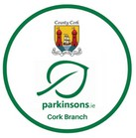
Parkinsons Awareness Month



We hope everyone is getting something positive from Parkinsons Awareness month 2025. This is why we have been a little late in getting out this month’s Parkinsons Ireland Cork Branch Newslatter!
We hope you celebrated in some way in particular World Parkinsons Day 11th April when we remember all those who are or who have been affected by Parkinsons. This date is the anniversary of the birthday of Dr James Parkinsons who first described in 1817 the condition that now bears his name in his “Essay on the Shaking Palsy”. It is still an interesting and relevant medical disposition.
Just to mention a few highlights in addition to our forthcoming annual mass celebration, the Walk in the Park for Parkinsons event on 5th April and Mary Ita’s family fun run on 13th April:

- DIFFERENT FOR EVERYONE: Parkinsons Ireland are again highlighting the important fact that Parkinsons can affect people in many different ways and can affect every single person with Parkinsons differently. It really is a “boutique illness”. It is complex, cruel and currently progressive and incurable so much more support, awareness and research is required, We need to keep pressing for more research and better and more effective practical treatments and support to help alleviate the pain, fear and discomfort that many endure. Parkinsons Disease is the fastest progressing neurological condition in the world. This year there are radio advertisements, many postings on social media and on www.parkinsons.ie A number of people affected by Parkinsons have recorded short 1 minute videos highlighting specific symptoms including Jackie and Jerome from Parkinsons Ireland Cork branch. Please ask all family and friends to keep a look out for these videos and please “like, share and comment”

- FEATURE ARTICLE IN THE EXAMINER We are very grateful first and foremost to Colm O’Cathain and also to journalist Sarah Horgan, photographer Chani Anderson and all at the Examiner for the extremely well written front page and page 7 article under the title “Young Parkinsons sufferer in Hell”. This hard hitting article highlighted the cruel situation of our 47 year old friend and member Colm O’Cathain who has been battling a particularly aggressive form of Young Onset Parkinsons disease for the past 10 years. Colm is now stuck in a relatively isolated nursing home for primarily elderly people, many of whom have dementia. His symptoms are severe and his situation is lonely and difficult. Colm bravely keeps his mind and his spirit as strong as he can. Colm was extremely brave and generous to meet Sarah and Chani with Jerome, to share his story in such a powerful way and to facilitate the deeply moving photographs which bring focus to the horrific nature of some of the challenges which Parkinsons may bring and the need for better and more effective supports.

- TIME TO TALK ABOUT PARKINSONS: ONLINE CONFERENCE We hope many of you received the links in our whats app groups and were able to log on to watch the excellent online conference held by Parkinsons Ireland on April 12th chaired by our own Cork member the wonderful Ann Marie O’Connor? The expert speakers on treatments for Parkinsons, exercise, medication, diet and gender-specific symptoms were very informative. The chat between Lisa Wynne (Parkinsons Ireland specialist nurse) Clare Bowles ( Irish Rugby international-whose Dad has Parkinsons) and Annmarie was also positive and interesting.

- FURTHER ACTIVITIES & EVENTS: There are many interesting talks, activities and events around the world which you can still engage with online or otherwise. Many areavailable on playback through links on
Parkinsons Ireland or other reputable Parkinsons related websites such as Fox Foundation, Move4parkinsons, World Parkinsons Coalition, Parkinsons UK, Cure for Parkinsons, PD Avengers, European Parkinsons Disease Association and others. Please do continue to talk about Parkinsons and to keep Parkinsons in the spotlight.

April 2025
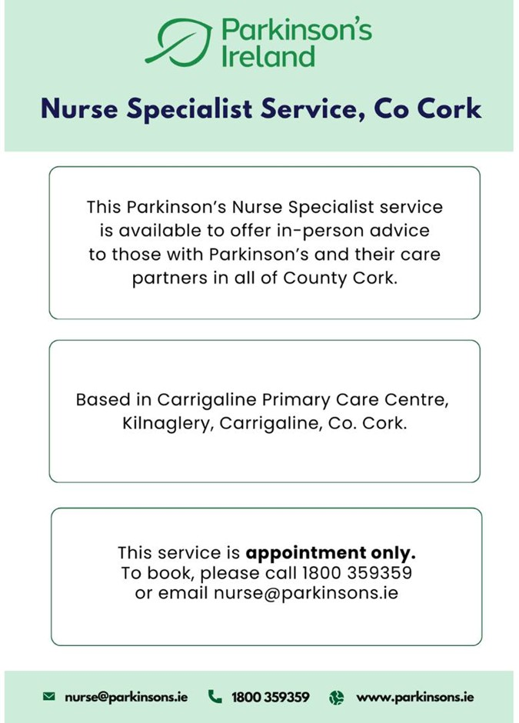

April 2025
INFORMATION MEETING NO.4 MAY 11TH 2.30 -5.00 (Doors open 2.00 -tea break 3,30 to 4.00)
SACRED HEART PARISH HALL VICTORIA CROSS CORK

SPECIAL GUEST SPEAKERS: DR. DIANA OLSZEWSKA Consultant Neurologist, Movement Disorders Specialist, Cork University Hospital and Parkinsons Disease Research Cluster, University College Cork
DR. FIADHNAIT O’KEEFFE
Senior Lecturer in Clinical Psychology UCC, Chartered Clinical Neuropsychologist & Chartered Clinical Pscychologist
We are deeply honoured and privileged to have two top world class expert speakers at our next information meeting who will give extremely relevant and interesting presentations for all of us living with Parkinsons Disease. We are delighted that our series of information meetings have proved so positive, popular, interesting, stimulating and truly worthwhile.
There will also be our information stand well stocked with Parkinsons Ireland information leaflets, slide shows of our classes, activities and events and most importantly a chance for a cup of tea and a chat with others affected by Parkinsons and to exchange information and support. We may even have our traditional song, dance and a few stretches!

THERE IS NO CHARGE AS OUR SPEAKERS KINDLY GIVE THEIR TIME FOR FREE AND EVERYONE IS WELCOME-PEOPLE AFFECTED BY PARKINSONS, FAMILY, FRIENDS, CLINICIANS, STUDENTS, RESEARCHERS. -DON’T MISS IT!!

PARKINSONS IRELAND SOCIAL GATHERING HODSON BAY HOTEL -BOOK NOW!
WE WOULD LIKE TO ENCOURAGE MEMBERS TO PLEASE BOOK IN AS EARLY AS POSSIBLE FOR THE FANTASTIC PARKINSONS IRELAND ANNUAL SOCIAL GATHERING IN HODSON BAY HOTEL ATHLONE.
It would be lovely to have a real presence from Parkinsons Ireland Cork Branch to share this fabulous annual occasion with friends from around Ireland. It is great value for dinner, bed & breakfast over two days in such a lovely hotel with leisure facilities in a beautiful setting, interesting information sessions, dancing and entertainment both nights and most importantly a chance to socialise and exchange mutual support with fellow members of Parkinsons Ireland and HQ staff.
FURTHER DETAILS IN THE PARKINSONS IRELAND SPRING QUARTERLY MAGAZINE OUT NOW OR
AVAILABLE ON www.parkinsons.ie -services-newsletters & magazines
We have taken the liberty of copying the announcement in the Parkinsons Ireland magazine on the next page.
All golfers please also note the announcement from the Parkinsons Ireland website about the Irish Parkinsons Golf Network which is getting active again for the summer. There is an outing planned for Tullamore on 17th April and also on the last day of the Social Gathering in Athlone Golf course adjoining the Hodson Bay Hotel!

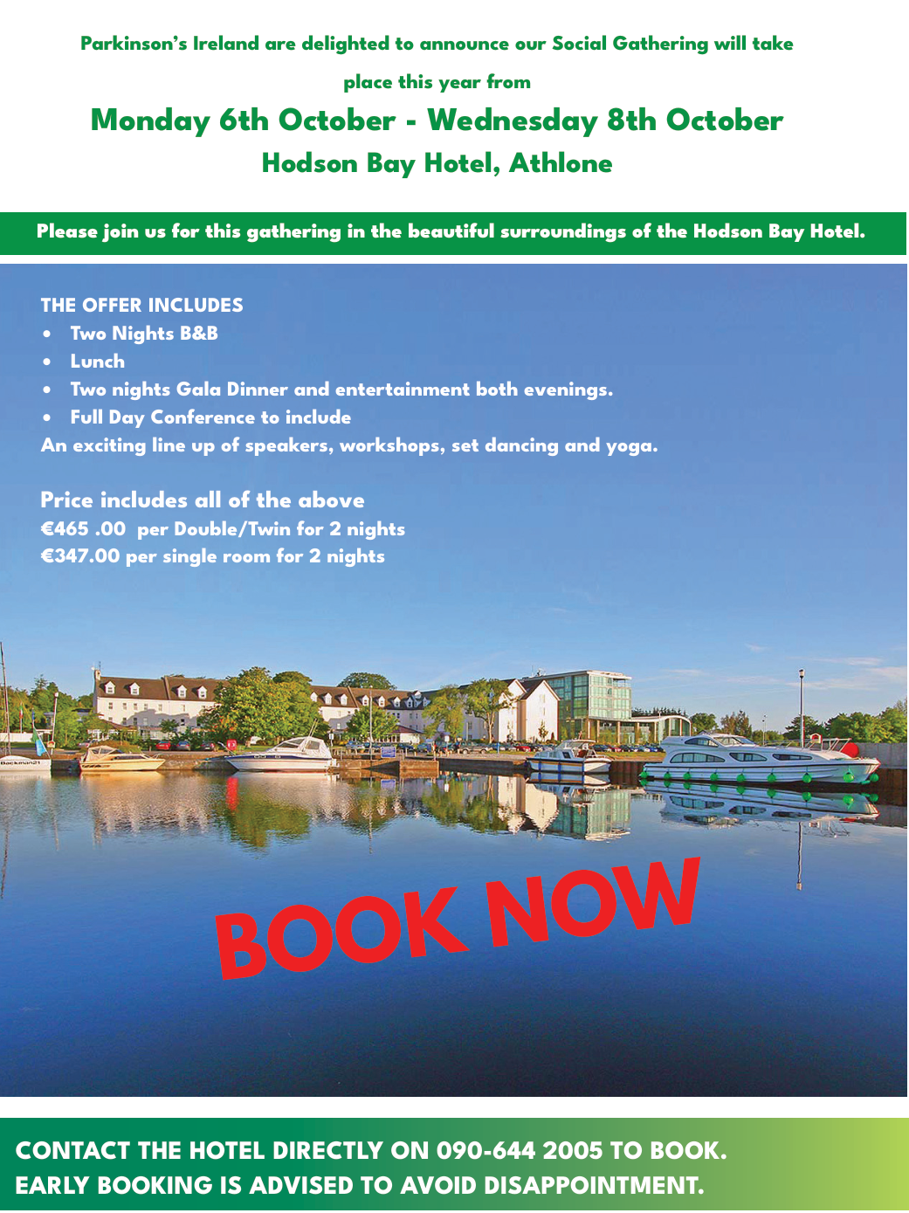
.



www.parkinsons.ie
April 2025

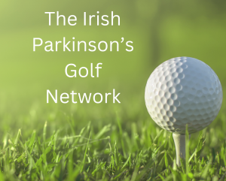

The Irish Parkinson’s Golf Network
The Irish Parkinson’s Golf Network brings together golfers who live with Parkinson’s, their spouses, partners and care partners in an environment that promotes social golf and to make PD golfers aware of others in their locality.

We have around 30 active members and this year aim to have 5 outings. The first will be in Tullamore Golf Club on 16th April and our final one will coincide with the meeting in October in Athlone. The other outings have yet to be confirmed.

This is open to any Parkinson’s golfer of any standard. All are welcome, new members always encouraged.
Contact details: irishparkinsonsgolfnetwork@gmail.com or cormacmehigan@btinternet.com



FUTURE EVENTS
www.parkinsons.ie
April 2025

JUNE-PDRC OPEN DAY
JULY -BRANCH OUTING-COBH
WEST CORK GATHERING
NORTH CORK GATHERING
AUGUST- GATHERINGS
SEPTEMBER-AGM & OPEN FORUM-PRESENTATION ON BRANCH CLASSES & ACTIVITIES, PARKINSONS IRELAND SERVICES & ONLINE CLASSES, PARKINSONS INFORMATION, ORGANISATIONS & INFORMATION ONLINE, HSE & THIRD PARTY SERVICES IN CORK OF POSSIBLE BENEFIT FOR PEOPLE WITH PARKINSONS
OCTOBER-INFORMATION MEETING NO.5-INSPIRATIONAL SPEAKER, EXPERT ON DRIVING ISSUES, RESEARCH SPEAKER, EXERCISE SPEAKER
NOVEMBER -ECUMENICAL SERVICE OF REMBRANCE & THANKSGIVING
DECEMBER-INFORMATION MEETING NO.6 NEUROLOGIST SPEAKER


We hope to see you all at some of the classes or events over the coming weeks.
PI Cork Branch Committee

Jerome Maume Jackie O’Reilly Des Donnelly Gearoid Duffy Tom Maher Diana Olszeswka

Queries should be emailed to jerome@parkinsons.ie or jackieoreilly@parkinsons.ie

